* **Please submit an Employment Detail Summary and Statement of Liability for 2021, from all employments held, which is obtained by logging onto** [**www.revenue.ie**](http://www.revenue.ie) **and following the below steps:**
* **Log into** [**www.revenue.ie**](http://www.revenue.ie)**, click on my account at the top of the page.**
* **Click on review your Tax for 2018 – 2021**

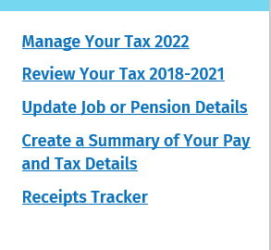

* **This brings you into the below screen and click on view Employment Detailed Summary and ensure the year is 2021**
* 